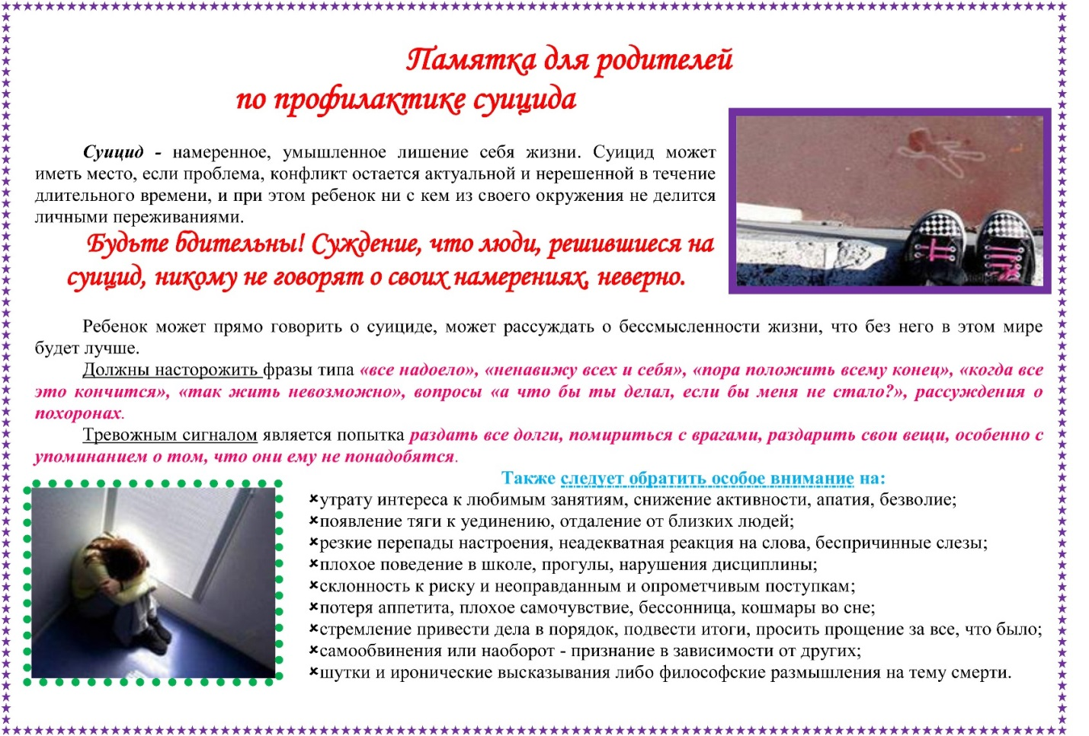



[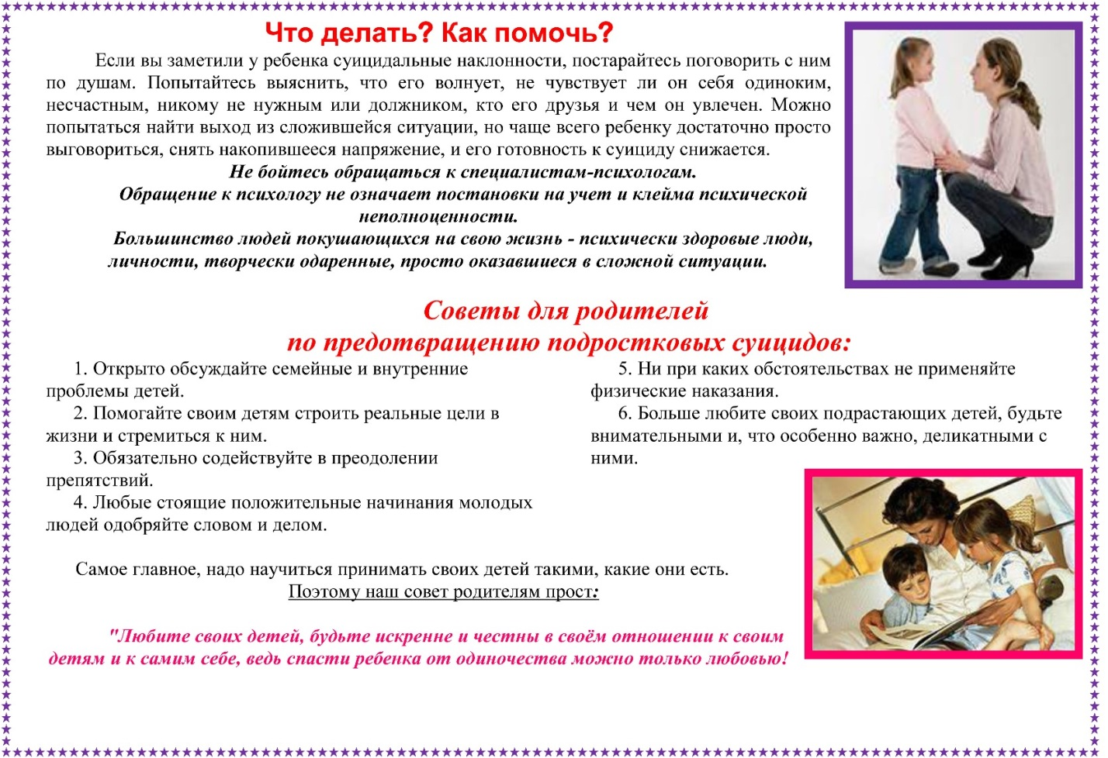](http://school6-sayansk.ru/images/roditelyam/pam2.jpg)

[](http://school6-sayansk.ru/images/roditelyam/pam2.jpg)